ROI = profit / investment

Rate of return on investment

Rate of return on equity

Reason of IT Payoff Measurement

1. competing investment
2. duration of payoff
3. overall economic picture

IT Investment Measurement

* profitability
  + C/B analysis, NPV
  + ROI, IRR
* Productivity
  + Efficiency
  + Quality
* Customer value
  + Greater loyalty & long-term retention

IT Payoff Paradox

Productivity Paradox

* The absence of a positive relationship between spending on information technology (IT) and its resulting contribution to productivity or profitability.

IT Investment

* investment decisions of allocating all types (i.e., human, monetary, physical) of resources to an IS

Competitive Advantage

* By helping stakeholders (stockholders + partnering companies) perform their biz functions much better
* Multiply the efficiency and productivities of one firm over another

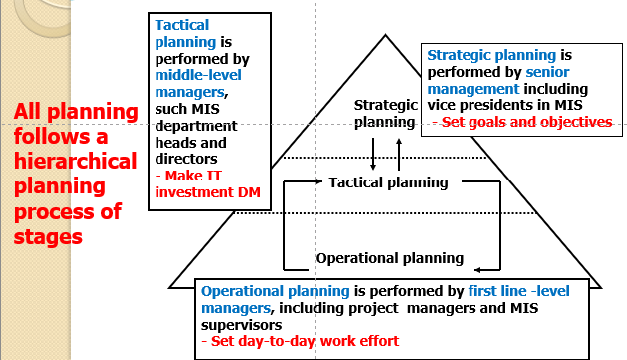

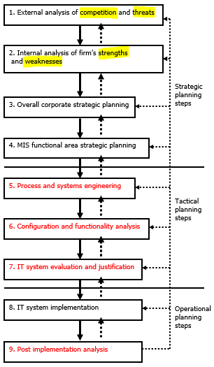

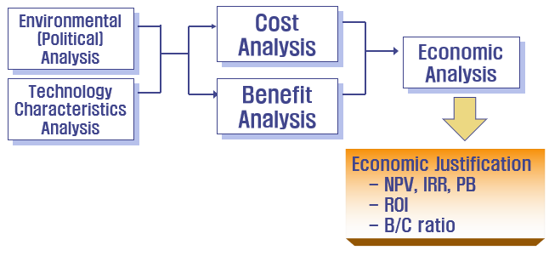

Economics of Information

* a systematic series of concepts and theories that explain the role which information and IT play to assist an organization

Effectiveness

Efficiency

Rule of thumb

Unit method

**CT = u** × **N** (cost of unit * number of unit)

Cost Index Method

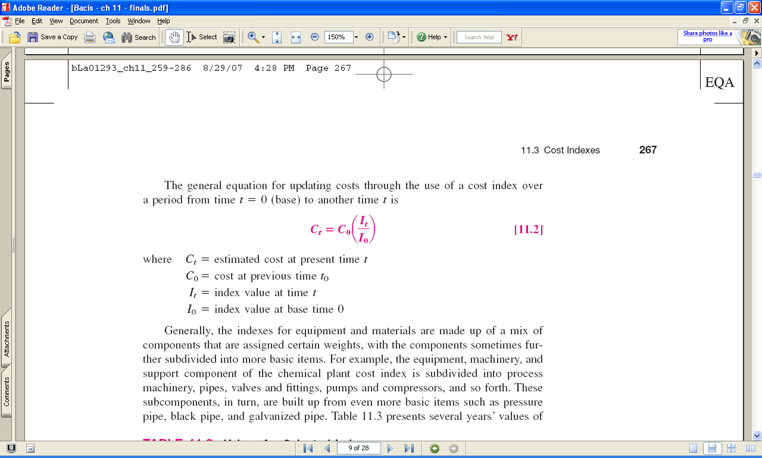 

Cost-capacity equation

x = 1, relationship is **linear**

x < 1, economies of scale (larger capacity is **less costly than linear**)

x > 1, diseconomies of scale

Factor method

**CT = h** × **CE**

Cost factor h, **h = 1 + Σ fi** (direct costs components)

indirect costs are charged separately against all direct costs, **CT = hCE(1 + findirect)**

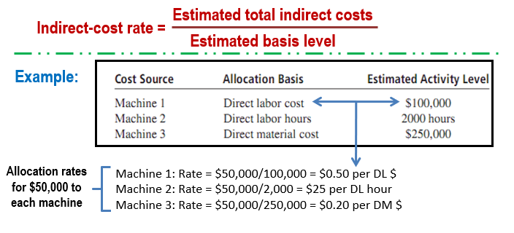

Steps to implement ABC:

1. Identify each ***activity*** and its ***total cost*** (e.g., maintenance at $5 million/year)

2. Identify ***cost drivers*** and expected ***volume***

(e.g., 3,500 requested repairs and 500 scheduled maintenances per year)

3. Calculate cost rate for each activity using the relation:

***ABC rate = total activity cost/volume of cost driver***

4. Use ***ABC rate*** to allocate IDC to ***cost centers*** for each activity

Depreciation.

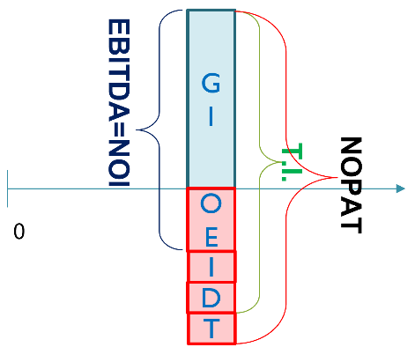

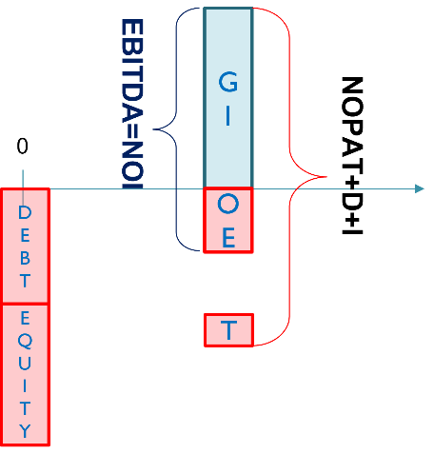 ROI

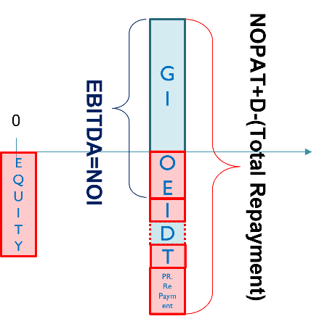 ROE

Step of B/C Analysis

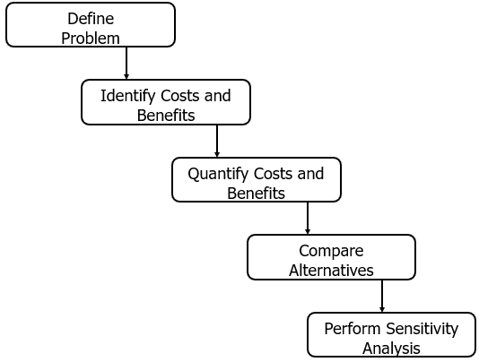

Analytic Hierarchy Process

Steps of the AHP

1. Set up decision hierarchy
2. Make pairwise comparisons of attributes and alternatives
3. Transform comparisons into weight & Score
4. Check consistency
5. Use weights to obtain priorities for options
6. Carry out sensitivity analysis

Multi factor scoring methods